

**PROJECT TITLE: MATRIMONY SERVICE**

**Submitted By**

Nafizul Islam

ID: 193-35-480

Batch: 30th

Department of Software Engineering

Daffodil International University

**Supervised By**

Mr. S A M Matiur Rahman

Associate Professor

Department of Software Engineering

Daffodil International University

This Report Presented in Partial Fulfillment of the Requirements for the Degree of Bachelor of Software Engineering.

Spring – 2023

Copyright © 2023 by Daffodil International University

**APPROVAL**

This thesis titled on “**Matrimony Service**”, submitted by **Nafizul Islam (ID: 193-35-480)** to the Department of Software Engineering, Daffodil International University has beenaccepted as satisfactory for the partial fulfillment of the requirements for the degree of Bachelor of Science in Software Engineering and approval as to its style and contents.

**BOARD OF EXAMINERS**

**---------------------------------------------------------** **Chairman**

**Nuruzzaman Faruqui**

**Assistant Professor**

Department of Software Engineering

Faculty of Science and Information Technology Daffodil International University

**---------------------------------------------------------** **Internal Examiner 1**

**Khalid Been Budruzzaman Biplob**

**Lecturer (Senor Scale)**

Department of Software Engineering

Faculty of Science and Information Technology

Daffodil International University

**---------------------------------------------------------** **Internal Examiner 2**

**Md Khaled Sohel**

**Assistant Professor**

Department of Software Engineering

Faculty of Science and Information Technology

Daffodil International University

**---------------------------------------------------------** **External Examiner**

**MD. Tanvir Quader.**

Solution Architect Engineer,

Technology Team, a2i Programme

ii

**DECLARATION**

I hereby affirm that this project has been completed under the supervision of Mr. S A M Matiur Rahman, Associate Professor at Daffodil International University. I declare that the project is entirely original and has not been submitted for any other degree or diploma. I take full responsibility for its authenticity and uniqueness.

**Supervised by:**

**Mr. S A M Matiur Rahman**

Associate Professor

Department of Software Engineering

Daffodil International University

**Submitted by:**

**Nafizul Islam**

ID: 193-35-480

Batch: 30th

Department of Software Engineering

Daffodil International University

iii

iv

**ACKNOWLEDGEMENT**

We begin by giving God the highest praise and gratitude for His wonderful blessings, which enabled us to successfully finish the senior project and internship.

We really appreciate Mr. S A M Matiur Rahman, Associate Professor, Department of Software Engineering, Daffodil International University, Dhaka, and express our gratitude and debt of gratitude to her. This endeavor was made possible by her never-ending patience, academic guidance, constant encouragement, frequent and energetic supervision, constructive criticism, helpful advice, reviewing numerous subpar drafts and fixing them at every stage.

We would like to extend our sincere gratitude to Professor Imran Mahmud, the head of the Software Engineering department, as well as to the other professors and staff members of the Software Engineering department at Daffodil International University, for your kind assistance in completing our research.

We'd like to thank all of our classmates at Daffodil International University who participated in this discussion while also attending class.

Finally, we must respectfully appreciate our parents' unwavering assistance and endurance.

v

**ABSTRACT**

The "Matrimony Service" project focuses on the development of a web-based platform exclusively tailored for the Bengali community, addressing their distinct requirements and preferences in the realm of matrimonial connections. With the increasing reliance on digital interactions and the shift towards paperless practices, there is a rising demand for a reliable and user-friendly platform in the matrimony domain. Thorough research and extensive feedback from potential users within the Bengali community have been gathered to ensure the system is precisely customized to their needs. The project incorporates open-source tools and technologies to implement a robust and scalable system, which has undergone comprehensive testing to ensure its effectiveness and functionality. Notably, the platform is designed to be intuitive and user-friendly, providing seamless communication and engagement with support for Bengali text. Moreover, the future roadmap of the project includes the integration of smartphone capabilities, enhancing accessibility and convenience for users. The overarching goal of the Matrimony Service project is to provide a secure and inclusive online platform that empowers individuals within the Bengali community to find compatible life partners through a culturally sensitive and user-centric approach.

**TABLE OF CONTENTS**

**Contents Page No**

APPROVAL………………………………………………………………………………..… ii

DECLARATION….……….....…………………………………………………………….... iii

ACKNOWLEDGEMENT………...…………………………………………………………. iv

ABSTRACT…………………………………………………………………...……………... v

LIST OF FIGURES………………………………………………………………………..… ix



* 1. Project Overview .........................................................................................................1

1.2 Purpose of the Project ..................................................................................................1

1.3 Scope of the Project .....................................................................................................1

1.4 Target Audience ….......................................................................................................1

1.5 Project Goals ................................................................................................................2



2.1 Functional Requirements .............................................................................................3

2.2 Non-Functional Requirements .....................................................................................3



3.1 System Architecture .....................................................................................................4

3.2 Database Schema …………………………………………………………………….4

3.3 Technology Stack ……………………………............................................................4

3.4 Data Flow Diagrams ....................................................................................................5

3.5 User Interface Design ..................................................................................................5

3.6 Use Case Model ...………............................................................................................5

3.7 Authentication and Account Management ..................................................................8

vi

**CHAPTER 3: SOFTWARE REQUIREMENT SPECIFICATIONS**

**08**

© Daffodil International University

3.8 Admin Panel Functionality..........................................................................................12

3.9 Account Verification …...............................................................................................15

3.10 Relationship Database Structure .................................................................................18

3.11 Matrimony Web Database ……..................................................................................21



4.1 Profile Creation and Editing .......................................................................................23

4.2 Uploading Photos ……................................................................................................23

4.3 Partner Preferences .....................................................................................................23

4.4 Privacy Settings ……..................................................................................................23



5.1 Basic Search ………………........................................................................................24

5.2 Advanced Search ........................................................................................................24

5.3 Matchmaking Algorithm .............................................................................................24

5.4 Matching Profiles ……................................................................................................24



6.1 Messaging System ……...….......................................................................................25

6.2 Expressing Interest ......................................................................................................25

6.3 Contacting Groom/Bride or Family ............................................................................25

6.4 Chat Features ……......................................................................................................26



7.1 Membership Levels .....................................................................................................27

7.2 Subscription Plans ……...............................................................................................27

7.3 Payment Gateway …...................................................................................................28

7.4 Membership Renewal and Cancellation …….............................................................28

vii



8.1 Data Security Measures ………….…….....................................................................29

8.2 Privacy Policy …….....................................................................................................29

8.3 GDPR Compliance ......................................................................................................29



9.1 Server Setup and Configuration …...……...................................................................30

9.2 Continuous Integration/Continuous Deployment (CI/CD) .........................................30

9.3 Release Management ..................................................................................................30



10.1 Bug Tracking and Issue Resolution ...….....................................................................31

10.2 Feature Updates and Enhancements ...........................................................................31

10.3 Customer Support .......................................................................................................31



11.1 Project Summary ...…..................................................................................................32

11.2 Lessons Learned ..........................................................................................................32

11.3 Future Roadmap ..........................................................................................................32



12.1 User Interface …....…..................................................................................................33

12.2 Code Samples ………….….........................................................................................40

12.3 References and Citations ….........................................................................................43

viii

|  |  |
| --- | --- |
| **FIGURES** | **PAGE NO** |
| Figure 3.1: Use Case Diagram | 7 |
| Figure 3.2: Login Verify Activity Diagram | 9 |
| Figure 3.3: Visitor Activity Diagram | 10 |
| Figure 3.4: Member Activity Diagram | 11 |
| Figure 3.5: Management Sequence Diagram | 14 |
| Figure 3.6: Login Successfully Sequence Diagram | 17 |
| Figure 3.7: ER Diagram | 20 |
| Figure 3.8: UML Diagram | 22 |
| Figure 3.9: Database Table List | 22 |
| Figure 12.1.1: Home Page | 35 |
| Figure 12.1.2: Request Biodata Page | 35 |
| Figure 12.1.3: Registration Page | 36 |
| Figure 12.1.4: Login Page | 36 |
| Figure 12.1.5: User Account Page | 37 |
| Figure 12.1.6: Biodata Post Page | 37 |
| Figure 12.1.7: Search Page | 38 |
| Figure 12.1.8: Search Page | 38 |
| Figure 12.1.9: View Profile Page | 39 |
| Figure 12.1.10: Recent View Profile Portion | 39 |
| Figure 12.2.1: Partner File Portion | 41 |
| Figure 12.2.2: Login Authentication File Portion | 41 |
| Figure 12.2.3: View Profile Page File Portion | 42 |
| Figure 12.2.4: User Home Page File Portion | 42 |

**LIST OF FIGURES**

xi

ix

**CHAPTER 1**

**INTRODUCTION**

**1.1 Project Overview**

The Matrimony Web Service is an online platform designed to provide matrimony services exclusively for Bangladeshi Bengali communities. It enables users to search for potential grooms and brides, view their profiles, and contact their parents using phone numbers and email addresses. The project utilizes technologies such as HTML, CSS, PHP, JavaScript, MySQL, and Bootstrap.

**1.2 Purpose of the Project**

The purpose of the Matrimony Web Service is to facilitate the process of finding suitable life partners within the Bangladeshi Bengali community. By providing a convenient online platform, users can easily search for compatible matches, communicate with limited profiles, and benefit from various membership plans.

**1.3 Scope of the Project**

The scope of the project includes the development of a web service that allows users to create accounts, search for profiles based on different criteria (basic and advanced), view profile matches, and interact with other users through messaging. The project also encompasses the integration of manual payment gateways such as bKash, Rocket, Nagad, and other mobile banking options.

**1.4 Target Audience**

The target audience for the Matrimony Web Service is individuals within the Bangladeshi Bengali community who are seeking life partners. It caters specifically to those who prefer to connect with potential matches from their own community.

**1.5 Project Goals**

* The main goals of the Matrimony Web Service project are as follows:
* Develop a user-friendly web service for individuals seeking matrimonial matches within the Bangladeshi Bengali community.
* Implement a comprehensive search system, allowing users to find profiles based on specific biodata or advanced criteria.
* Enable users to contact the parents of potential grooms/brides through phone numbers and email addresses.
* Provide login and paid users with limited profile chatting functionality.
* Incorporate manual payment gateways (bKash, Rocket, Nagad, and others) to facilitate membership plan purchases.
* Display the percentage match between a user's profile and the profiles they visit.
* Offer membership plans allowing users to contact single or multiple profiles with different time limits and messaging quotas.

**CHAPTER 2**

**PROJECT REQUIREMENTS**

**2.1 Functional Requirements**

**User Registration:** Users should be able to create accounts on the platform.

**Profile Creation:** Users should be able to create their own profiles with biodata and other relevant information.

**Profile Search:** Users should be able to search for profiles based on specific biodata or advanced criteria (gender, religion, family class, district, occupation, etc.).

**Contact Information:** Users should have access to phone numbers and email addresses of groom/bride's parents to establish contact.

**User Messaging:** Logged-in and paid users should be able to send messages to limited profiles.

**Payment Gateway Integration:** The platform should support manual payment gateways (bKash, Rocket, Nagad, etc.) for purchasing membership plans.

Profile Matching: When a logged-in user visits another user's profile, the system should display the percentage match between the two profiles.

**Membership Plans:** The system should offer membership plans with different price points and durations, allowing users to contact single or multiple profiles and define messaging limits.

**2.2 Non-Functional Requirements**

**User Interface:** The web service should have an intuitive and visually appealing user interface.

**Security:** Appropriate security measures should be implemented to protect user data and payment transactions.

**Compatibility:** The web service should be compatible with popular web browsers and devices.

**Scalability:** The system should be designed to accommodate a growing number of users and profiles.

**CHAPTER 3**

**DESIGN AND ARCHITECTURE**

**3.1 System Architecture**

The system architecture of the Matrimony Web Service project will follow a typical client-server model. The client-side will be developed using HTML, CSS, JavaScript, and Bootstrap to create an interactive and user-friendly interface. The server-side will be built using PHP to handle the business logic, process requests, and interact with the database. MySQL will be used as the database management system to store user profiles, membership details, and other relevant information.

**3.2 Database Schema**

The database schema will include tables such as:

* Users: Stores user information, including personal details and login credentials.
* Profiles: Stores profile information, including biodata, gender, religion, family class, district, occupation, etc.
* Payments: Stores information related to user payments, including transaction details and payment statuses.

**3.3 Technology Stack**

* The technology stack for the Matrimony Web Service project includes:
* HTML: Markup language for structuring the web pages.
* CSS: Styling language for designing the user interface.
* PHP: Server-side scripting language for handling business logic and database interactions.
* JavaScript: Programming language for implementing client-side functionalities.
* MySQL: Relational database management system for storing and retrieving data.
* Bootstrap: Front-end framework for creating responsive and visually appealing designs.

**3.4 Data Flow Diagrams**

Data flow diagrams (DFDs) will illustrate the flow of data and processes within the system, including user registration, profile search, messaging, and payment processes. These diagrams will provide a visual representation of the system's functionalities and interactions.

**3.5 User Interface Design**

The user interface design will focus on providing a seamless and intuitive experience for users. It will incorporate a clean and user-friendly layout, allowing users to navigate through different sections of the website easily. The design will also prioritize responsiveness to ensure compatibility with various devices and screen sizes.

**3.6 Use Cases Model**

The matrimony web service is an online platform specifically designed for Bangladeshi Bengalis communities. It enables users to find potential life partners within their community. The system caters to three types of users: admin, visitors (without an account), and members (with an account).

They have the ability to log in to the system using their credentials and perform administrative tasks such as activating or deactivating user accounts, deleting accounts if necessary, viewing user profiles, and editing user biodata.

Visitors, who do not have an account, can explore the platform and access limited functionalities. They can view profiles and biodata of other users, request biodata or contact information from users, and have the option to log in or register for a new account.

Members, on the other hand, have registered accounts and can access additional features. They can register by providing their personal details and log in using their credentials. Once logged in, members have the ability to activate or deactivate their accounts, access their account settings and information, edit their own biodata, upload photos to their profiles, view their own profiles, and engage in chat-based communication with other members.

The use case diagram provides a visual representation of these user interactions and functionalities within the matrimony web service. It helps to illustrate the relationships and dependencies between the different user roles and their respective actions in the system.

**Admin:**

* Login: The admin can log in to the system to access administrative functionalities.
* Manage User Accounts: The admin can activate or deactivate user accounts and delete them if necessary.
* View Profile: The admin can view the profiles of users.
* Edit Biodata: The admin can modify the biodata of users.

**Visitors (Without Account):**

* Request Biodata/Contact: Visitors can send requests to obtain biodata or contact information from users.
* View Profiles/Biodata: Visitors can browse and view profiles and biodata of users.
* Login: Visitors can log in to the system using their credentials.
* Registration: Visitors can register and create a new account to become members.

**Members (Have an Account):**

* Registration: Members can register by providing their personal details.
* Login: Members can log in to their accounts.
* Account Activation/Deactivation: Members can activate or deactivate their own accounts.
* Access My Account: Members can access their account settings and information.
* Edit Biodata: Members can update their own biodata.
* Upload Photo: Members can upload photos on their profiles.
* View Profile: Members can view their own profiles and see their details.

View Profile

Request Biodata

Edit Biodata

Contact Us

Post Biodata

My Account

A/C Deactivate Account

A/C Active Account

tivate Account

Login

Registration

**Visitor**

**Member**

**Admin**

**Figure 3.1: Use Case Diagram**

**3.7 Authentication and Account Management**

The account management system in our matrimony web project plays a pivotal role in ensuring a secure and user-friendly experience for all members. With a focus on safeguarding user data, it offers essential functionalities for effortless account access and recovery. Here is a concise overview of the key aspects of this system:

**User Registration Process:**

The user registration process will involve a form where users can provide their personal details, including name, email, phone number and other required information. Upon submission, the system will validate the input data and create a new user account.

**Login and Logout Functionality:**

The login functionality will allow registered users to access their accounts by providing their credentials (email/username and password). Once logged in, users will have access to the features and functionalities of the web service. The logout functionality will enable users to securely log out of their accounts.

**Account Verification:**

After registration, users may need to verify their email address to activate their accounts. The system will send a verification link to provided email, and users will need to click on the link to verify their accounts.

**Password Recovery:**

In case users forget their passwords, a password recovery mechanism will be implemented. Users can initiate the password recovery process by providing their email address. The system will send a password reset link to the provided email, allowing users to reset their passwords securely.

Login

Verify

View Member Account

Authentication

Logout

View Visitor Account

Activate Account

Deactivate Account

**Figure 3.2: Login Verify** **Activity Diagram**

START

If

Register

Yes

No

Home

About Us

Contact Us

Contact Biodata

Chatting

Register

View Profile

Search Biodata

FAQ

Login

Verify

Authentication

Login Success

Logout

STOP

**Figure 3.3: Visitor** **Activity Diagram**

Login

Verify

Partner Alert

Search

My Account

Update Biodata

Post Biodata

View Profile

Authentication

Edit Account

Chatting

Logout

**Figure 3.4: Member** **Activity Diagram**

**3.8 Admin Panel Functionality**

This section outlines the functionality of the admin panel in the Matrimony Web Project, which is responsible for managing various aspects of user profiles and content. The admin panel allows administrators to perform tasks such as user authentication, searching for partners, managing user registrations, profile information, photos, and documents. Each functionality is described in detail with a sequence of actions taken by the system and the admin to accomplish these tasks efficiently and securely. The following subheadings cover the key functionalities of the admin panel:

**Login Success:**

The system receives the login request and verifies the entered credentials. The system checks the database for the admin's email address and retrieves the associated password hash. The system compares the entered password with the stored hash to authenticate the admin. If the credentials are valid, the system generates a session token and associates it with the admin's session. The system grants access to the admin panel and redirects them to the dashboard.

**Search Partners:**

The admin navigates to the search partners section in the admin panel. The system presents a search form where the admin can enter criteria to find user profiles. The admin submits the search form to initiate the search process. The system retrieves user profiles from the database based on provided search criteria. The system displays the search results, including relevant profile information, to the admin.

**Registration Management:**

The admin accesses the registration management section in the admin panel. The system retrieves a list of newly registered user accounts from the database. The admin can view details of individual registrations and perform actions such as approving or rejecting them. If approved, the system marks the user account as verified in the database, allowing them to log in. If rejected, the system may delete the user account or notify the user about the rejection.

**Profile Management:**

The admin selects a user profile from the search results or registration management section. The system retrieves the user's profile information, including personal details and preferences. The admin can view and modify the user's profile information based on provided permissions. The system updates the user's profile data in the database upon admin's modifications.

**Photo Management:**

The admin navigates to the photo management section in the admin panel. The system retrieves a list of user profiles that have uploaded photos awaiting approval. The admin can view the uploaded photos and perform actions such as approving or rejecting them. If approved, the system marks the photos as verified and associates them with the user's profile. If rejected, the system may delete the photos or notify the user about the rejection.

**Document Management:**

The admin accesses the document management section in the admin panel. The system retrieves a list of user profiles that have submitted documents for verification. The admin can view the submitted documents and perform actions such as approving or rejecting them. If approved, the system marks the documents as verified and associates them with the user's profile. If rejected, the system may delete the documents or notify the user about the rejection.

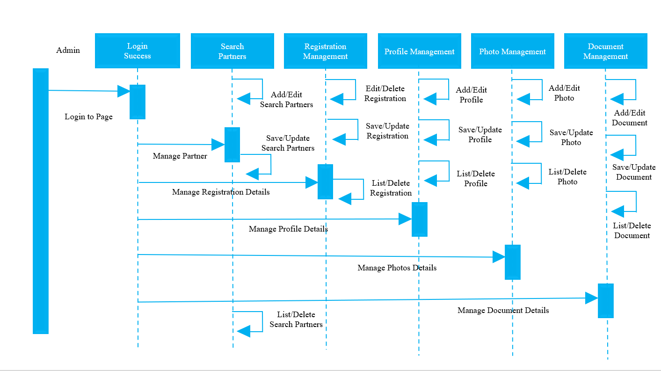

**Figure 3.5: Management Sequence Diagram**

**3.9 Account Verification**

This section describes the process of user login and account verification in the Matrimony Web Project. It outlines the steps taken by the system to authenticate users during login and how user accounts are verified to ensure legitimate registrations. The following subheadings cover the key functionalities related to user login and verification:

**User Login:**

The user enters their email address and password on the login page. The system receives the login request and verifies the entered credentials. The system checks the database for the user's email address and retrieves the associated password hash. The system compares the entered password with the stored hash to authenticate the user. If the credentials are valid, the system generates a session token and associates it with the user's session. The system grants access to the user's account and redirects them to the home page.

**Forgot Password:**

If the user forgets their password, they can click on the "Forgot Password" link on the login page. The system presents a form where the user can enter their registered email address. The user submits the form to initiate the password reset process. The system generates a unique verification code and sends it to the user's email address. The system prompts the user to enter the verification code received via email. The user enters the code in the provided field and submits the form. The system verifies the entered code against the generated code. If the code is valid, the system allows the user to reset their password.

**Verification:**

During the registration process, the system generates a verification link for the user. The system sends the verification link to the user's provided email address. The user receives the verification email and clicks on the link to verify their account. The system receives the verification request and marks the user's account as verified in the database. The system may redirect the user to a confirmation page or the login page upon successful verification.

**Database:**

The system interacts with the database to store and retrieve user related information When a user registers, their account details, including email address, password hash, and verification status, are stored in the database. During login, the system retrieves the user's information from the database for authentication. The database stores additional user data, such as profile information, preferences, and communication history.

**Authentication:**

The system uses various authentication mechanisms, such as password hashing and session tokens, to ensure secure access. Passwords are stored in a hashed form in the database to protect user data. Upon successful login, the system generates a session token associated with the user's session for subsequent requests. The session token is validated for each request to authenticate the user and grant access to authorized resources.

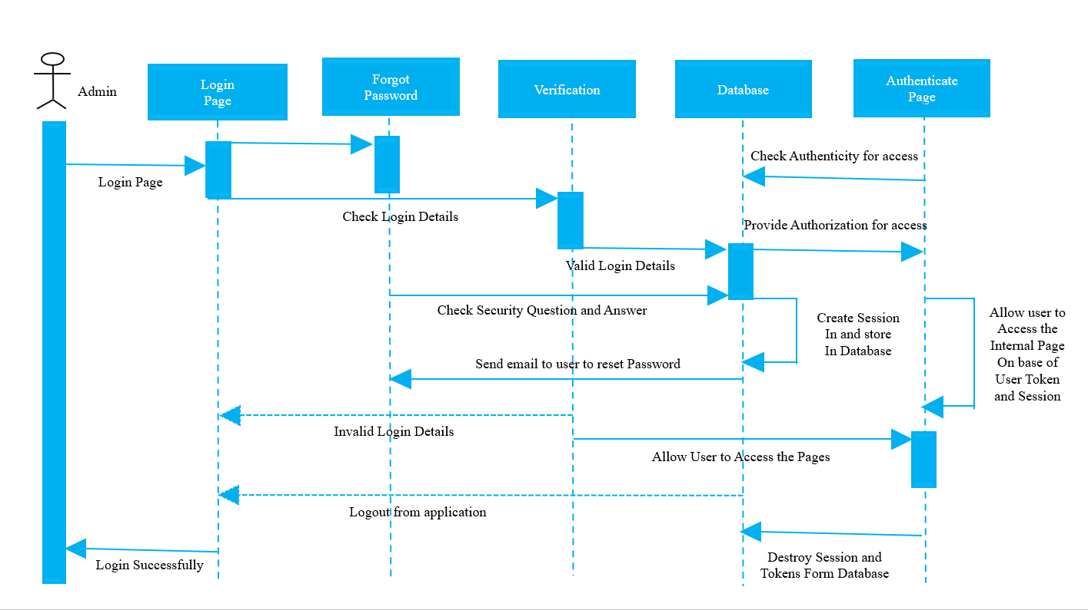

**Figure 3.6: Login Successfully Sequence Diagram**

**3.10 Relationship Database Structure**

This section illustrates the ER Diagram for the web project, demonstrating the relationships between various entities such as Customer, Users, Contact Us, Messages, Photos, Address Details, Family Details, Religious Information, Expected Life Partner, Personal Physique, Personal Lifestyle, Higher Secondary Edu, Kowmi Madrasa Edu, Secondary Edu Method, and University Edu Method. The ER Diagram visually represents the database structure, facilitating data management and retrieval based on user profiles and related information.

**Customer:** Represents the registered users of the platform. Each customer has a unique ID assigned as the primary key.

**Users:** Includes both regular users and administrators. Users have a unique ID, username, and password for authentication purposes. Administrators have additional privileges and can manage various aspects of the platform.

**Contact Us:** Tracks user inquiries and feedback. Each contact entry has a unique contact ID and is associated with a specific user through a foreign key relationship.

**Messages:** Stores the messages exchanged between users. Each message is identified by a unique message ID and is associated with the sender and receiver.

**Photos:** Contains the photos uploaded by users. Each photo has a unique ID and is associated with the user who uploaded it.

**Address Details:** Stores the address information of users. Each address entry is linked to a specific user.

**Family Details:** Gathers information about the familial background of users. Each entry on family information is linked to a specific user.

life partner entry is associated with a user.

**Personal Physique:** Includes information about the physical characteristics of users.

**Personal Lifestyle:** Captures information about the lifestyle and habits of users.

**Higher Secondary Edu, Kowmi Madrasa Edu, Secondary Edu Method, and University Edu Method:** These entities store information related to users' educational backgrounds and methods of education. The relationships between the entities are established through primary key and foreign key associations. For example, the Users table serves as the primary entity and

other tables have foreign key references to link their data with specific users. The relationships enable data retrieval and manipulation based on user profiles, messages, photos, and other relevant information.

**Religious Information:** Documents the religious affiliations of users. Each entry on religion details is associated with a particular user.

**Expected Life Partner:** Represents the preferences and expectations of users regarding their potential life partners. Each expected

Login_role_id

#login_id

Login_username

Luser_password

number

email

#User_id

fullname

gender

username

Login_email

Has

User

Login

User_id

#photo_id

#reg_id

partner_financial

partner_education

#partner_id

partner_height

partner_religius

reg_desc

#customer_id

fname_customer

number_customer

payment

request_biodata_number

email_customer

Registration

Contact Profile

Partners

Photo

partner_district

partner_age

reg_type

pic1

Has

Manage

**Figure 3.7: ER Diagram**

**3.11 Matrimony Web Database**

The UML (Unified Modeling Language) diagram for the Matrimony Web Database represents the structure and relationships between various entities in the database. It includes tables such as customer, users, contact us, messages, photos, address details, family information, religion details, expected life partner, personal physical, personal lifestyle, higher secondary education method, kowmi madrasa education method, secondary education method, university education method, admin, marital status, marriage related questions male and marriage related questions female.

The UML diagram showcases the primary keys (underlined) and the indexes (marked as keys) for each table, indicating the fields that uniquely identify records and enable efficient data retrieval. The relationships between tables are not explicitly shown in this script, but the UML diagram will illustrate how different entities are associated through primary key and foreign key relationships. The UML diagram is an essential visual representation that aids in understanding the database structure and interactions between various components, ensuring effective data management for the Matrimony Web Project.

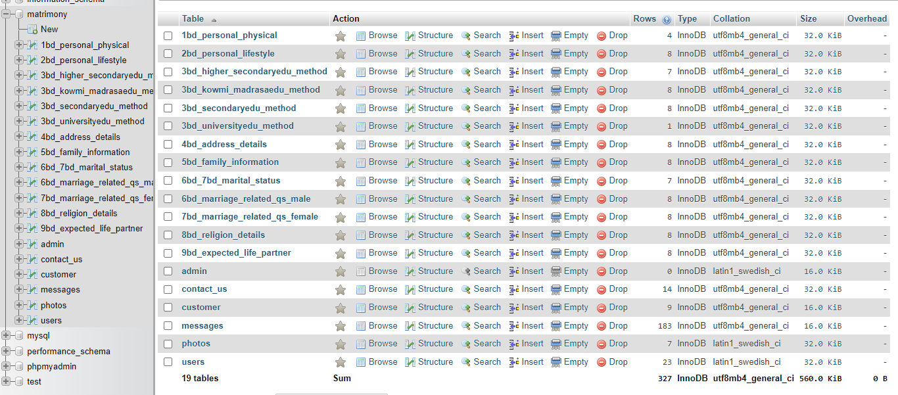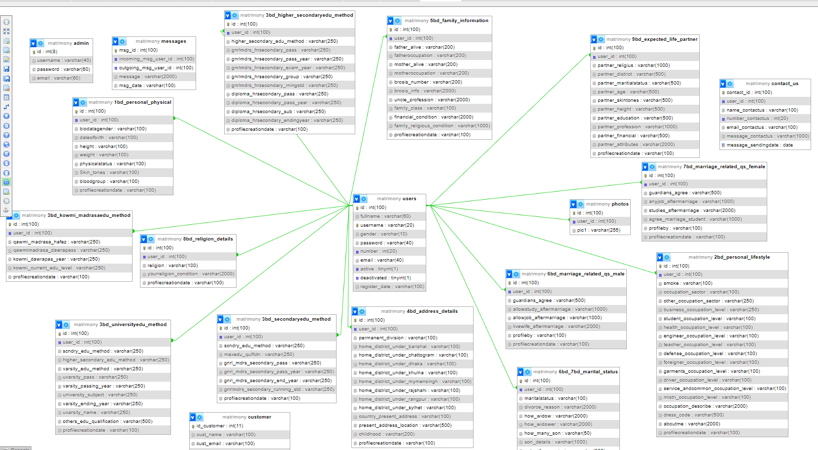

**Figure 3.9: Database Table List**

**Figure 3.8: UML Diagram**

**CHAPTER 4**

**USER PROFILE MANAGEMENT**

**4.1 Profile Creation and Editing**

In the matrimony web service, users can create their profiles by providing necessary information such as personal details, education, occupation, and more. They can fill in the required fields and save their profile information. Additionally, users have the ability to edit their profiles to update or modify any information whenever needed.

**4.2 Uploading Photos**

Users are allowed to upload their photos to enhance their profiles. They can choose to upload multiple photos and have the flexibility to update or delete them as desired. By adding photos, users can provide a visual representation of themselves to other members of the matrimony service.

**4.3 Partner Preferences**

In the profile management section, users can specify their partner preferences. They can set criteria such as age range, religion, family class, district, occupation, and other relevant preferences. By providing these preferences, users can narrow down their search results and increase the chances of finding a suitable match.

**4.4 Privacy Settings**

The matrimony web service prioritizes user privacy and ensures that sensitive information, such as users' email addresses, phone numbers, and full names, remain hidden from other users. The privacy settings are designed in a way that only authorized administrators can access and manage this information. This approach safeguards user data and maintains the confidentiality of personal details.

**CHAPTER 5**

**SEARCH AND MATCHMAKING**

**5.1 Basic Search**

Users, including both members and non-members, can perform a basic search on the matrimony web service. They have the option to search for specific biodata profiles using an ID number. This feature allows users to directly find and view a particular profile by entering the unique ID associated with that profile.

**5.2 Advanced Search**

The advanced search functionality provides users with more refined search options. Users can search for potential matches based on criteria such as gender, religion, family class, district, occupation, and more. This allows users to narrow down their search results and find profiles that closely match their preferences.

**5.3 Matchmaking Algorithm**

The matrimony web service employs a matchmaking algorithm to suggest potential matches to users based on their profile information and partner preferences. The algorithm takes into account various factors and criteria to generate accurate and relevant match suggestions for users.

**5.4 Matching Profiles**

When a logged-in user visits another user's profile, the matrimony web service calculates and displays the percentage of compatibility between the visitor's profile and the profile being viewed. This percentage indicates how well the two profiles match based on shared preferences and criteria. It provides users with a quick overview of their compatibility with a potential match.

**CHAPTER 6**

**COMMUNICATION**

**6.1 Messaging System**

The matrimony web service features an exclusive messaging system accessible to registered and paid users. To ensure privacy and maintain a secure environment, the messaging functionality is restricted to authenticated users who have created an account and purchased a membership plan. Visitors to the website can explore the available profiles and browse basic information but cannot access the messaging feature without logging in or creating an account. Once users have successfully registered and purchased a membership plan, they will gain access to the messaging system, which serves as a private and secure platform for communication. This messaging system enables users to engage in meaningful conversations, express their interests, and take the initial steps towards establishing connections and finding suitable matches within the Bangladeshi Bengali community. By requiring account login and membership purchase, the matrimony web service ensures that messaging privileges are exclusively granted to committed users, enhancing the authenticity and quality of interactions on the platform.

**6.2 Expressing Interest**

Users have the option to express their interest in a particular profile. They can show their interest by clicking on a designated button or feature, indicating their attraction or desire to connect with the other user. This feature serves as an initial step towards initiating communication and expressing their intention for further interaction.

**6.3 Contacting Groom/Bride or Family**

In the matrimony web service, instead of having an explicit "accepting" or "declining" system for interests, the platform provides an alternative method for users or visitors to contact the groom/bride or their family. When a member or visitor expresses interest in a particular profile, they can refer to the website's policy on how to contact that specific profile. The policy will outline the steps to follow for contacting the desired profile.

To initiate contact, members or visitors will need to make the payment manually. Once the payment is made, the website administrator will verify the payment information. After verification, the administrator will share the groom/bride's email address and parents' contact number via SMS or email to the member or visitor who made the payment. This ensures that the communication process is closely monitored and validated by the website administrator, maintaining the privacy and security of the parties involved.

**6.4 Chat Features**

Once users have established a mutual interest and connection, they can engage in real-time chat conversations. The matrimony web service offers chat features that enable logged-in and paid users to communicate with each other seamlessly. These chat features allow users to have private conversations, fostering better interaction and facilitating the process of getting to know potential matches.

**CHAPTER 7**

**MEMBERSHIP AND SUBSCRIPTION**

**7.1 Membership Levels**

The matrimony web service offers two membership levels to cater to users' needs: the Single Profile Plan and the Multiple Profiles Plan. Users can choose the plan that best suits their requirements and preferences.

**Single Profile Plan:**

* With the Single Profile Plan, users can contact and connect with a single profile of their choice within the Bangladeshi Bengali community.
* This plan allows users to express their interest in selected profile and wait for a maximum of 48 hours for the administration to verify the payment information.
* Once the payment is successfully verified, the administration will provide the contact information of the chosen profile to the user.

**Multiple Profiles Plan:**

* The Multiple Profiles Plan enables users to contact and connect with multiple profiles within the Bangladeshi Bengali community.
* Users the Multiple Profiles Plan have the privilege to initiate conversations and engage in meaningful communication with the selected profiles.
* This plan grants users access to the messaging feature, allowing them to chat with the limited profiles they have chosen.

**7.2 Subscription Plans**

Users can subscribe to various subscription plans based on their desired level of access and benefits. Subscription plans typically include different durations and pricing options to accommodate users with different preferences and budgets. These plans provide enhanced functionality and additional features beyond what is available to non-subscribing users.

**7.3 Payment Gateway**

To facilitate secure and convenient payments, the matrimony web service integrates with popular payment gateways, such as Bkash, Roket, and Nagod mobile banking, that are widely accepted in Bangladesh. This integration allows users to make payments for membership subscriptions or other services using their preferred payment methods.

**7.4 Membership Renewal and Cancellation**

Users have the option to renew their membership subscriptions based on their preferences. The matrimony web service provides a streamlined process for membership renewal to ensure uninterrupted access to services. However, users cannot cancel their membership plans once purchased. This policy ensures consistency in the service and maintains fairness for all users.

**CHAPTER 8**

**SECURITY AND PRIVACY**

**8.1 Data Security Measures**

The matrimony web service prioritizes the security of user data by implementing robust data security measures. These measures include encryption techniques, secure database management, and regular backups to protect user information from unauthorized access, breaches, or data loss. By employing industry-standard security practices, the web service ensures the confidentiality, integrity, and availability of user data.

**8.2 Privacy Policy**

To maintain transparency and establish trust with users, the matrimony web service has a comprehensive privacy policy in place. The privacy policy outlines how user data is collected, stored, and used within the platform. It also clarifies the purpose of data collection and the rights of users in controlling their personal information. The privacy policy adheres to applicable laws and regulations to safeguard user privacy.

**8.3 GDPR Compliance**

The matrimony web service ensures compliance with the General Data Protection Regulation (GDPR) guidelines, which protect the privacy and rights of individuals within the European Union (EU) and European Economic Area (EEA). The platform implements necessary measures to handle personal data in accordance with GDPR requirements, including obtaining explicit consent, providing data access and deletion options, and implementing data protection measures.

**CHAPTER 9**

**DEPLOYMENT AND RELEASE**

**9.1 Server Setup and Configuration**

The matrimony web service undergoes a server setup and configuration process to ensure a reliable and efficient deployment. This involves selecting appropriate server hardware, configuring the server software, setting up the required databases, and optimizing the server environment for optimal performance and scalability.

**9.2 Continuous Integration/Continuous Deployment (CI/CD)**

To streamline the development and deployment process, the matrimony web service employs a continuous integration/continuous deployment (CI/CD) approach. CI/CD allows for automated building, testing, and deployment of new code changes, ensuring a smooth and efficient development workflow. This methodology helps in minimizing errors and ensuring that new features and updates are seamlessly integrated into the production environment.

**9.3 Release Management**

Effective release management is implemented to control the deployment and rollout of new features, updates, and bug fixes. This involves planning and coordinating the release process, ensuring thorough testing and quality assurance, and minimizing any disruption to the live system. Release management aims to deliver a stable and reliable matrimony web service to users while managing the risks associated with deploying new changes.

**CHAPTER 10**

**MAINTENANCE AND SUPPORT**

**10.1 Bug Tracking and Issue Resolution**

To ensure the smooth functioning of the matrimony web service, a robust bug tracking and issue resolution system is in place. This system allows users and administrators to report any encountered bugs or issues. The reported issues are logged, tracked, and promptly addressed by the development team. Regular testing and debugging processes help to identify and resolve bugs efficiently, ensuring a high-quality user experience.

**10.2 Feature Updates and Enhancements**

The matrimony web service is committed to continuous improvement and staying up-to-date with evolving user needs. Regular feature updates and enhancements are implemented to introduce new functionalities and improve existing features. User feedback and market trends are taken into consideration to identify areas for improvement. These updates and enhancements aim to provide users with an enriched experience and maintain the competitiveness of the web service.

**10.3 Customer Support**

A dedicated customer support system is available to address user queries, provide assistance, and offer guidance. Users can reach out to the customer support team through various channels, such as email, phone, or a support ticket system. The customer support team is trained to provide prompt and helpful responses, ensuring a positive user experience and resolving any issues or concerns that may arise.

**CHAPTER 11**

**CONCLUSION**

**11.1 Project Summary**

In summary, the matrimony web service is a platform designed to cater exclusively to the Bangladeshi Bengali community. It allows users to connect with groom/bride parents through provided phone numbers and email addresses. Registered users have the flexibility to upload or delete their photos and update their biodata at any time. Additionally, users can deactivate or reactivate their accounts as per their preference. The project ensures the security and privacy of user registration information, protecting it from any unauthorized access or attacks.

**11.2 Lessons Learned**

Throughout the development of the matrimony web service, several valuable lessons have been learned. These include the importance of user feedback, the significance of robust security measures, the need for continuous testing and bug resolution, and the benefits of providing efficient customer support. These lessons have contributed to the project's growth and success.

**11.3 Future Roadmap**

Looking ahead, the matrimony web service has a clear future roadmap. This includes plans to further enhance the user experience by introducing new features and functionalities. The project team aims to continue improving the platform based on user feedback and emerging market trends. The future roadmap also involves staying up-to-date with the latest technologies and ensuring the long-term sustainability and success of the matrimony web service.

**CHAPTER 12**

**APPENDICES**

**12.1 User Interface**

The user interface of our matrimonial web project has been meticulously designed to provide a visually appealing and user-friendly experience for our users. The interface embodies a modern and elegant design, ensuring a pleasant and engaging journey for those seeking their life partners.

Upon landing on the home page, users are greeted with a captivating layout that combines vibrant colors, enticing imagery, and clear typography. The user-centric design approach immediately grabs the user's attention and invites them to explore the platform further.

The navigation menu, strategically placed at the top of the page, offers easy access to key sections of the website. Users can effortlessly navigate to search for matches, manage their profile, explore communication features, and access helpful resources.

The search functionality is a prominent feature, allowing users to refine their partner preferences and find compatible matches. The search filters enable users to specify criteria such as age, religion, education, and more, ensuring personalized and tailored search results.

Profiles are elegantly displayed, showcasing essential details and captivating profile pictures. The profile view provides a comprehensive overview of the individual, including their personal information, family background, education, and partner preferences. Users can easily browse through profiles and initiate communication with potential matches.

The messaging system offers a seamless and secure platform for users to connect and interact with each other. It allows for private conversations, ensuring confidentiality and privacy in their discussions. The messaging interface is intuitive and user-friendly, enabling users to send messages, view conversation history, and receive real-time notifications.

The user interface also includes features for account management, such as profile editing, privacy settings, and notifications preferences. Users can effortlessly update their information, manage their photo albums, and customize their account settings to suit their preferences.

A dedicated section for success stories and testimonials showcases real-life experiences and serves as an inspiration for users, reinforcing trust and credibility in the platform.

Overall, the user interface of our matrimonial web project combines visually appealing design elements with intuitive functionality. It provides a seamless and enjoyable experience for users to explore, connect, and find their life partners within a safe and secure online environment.

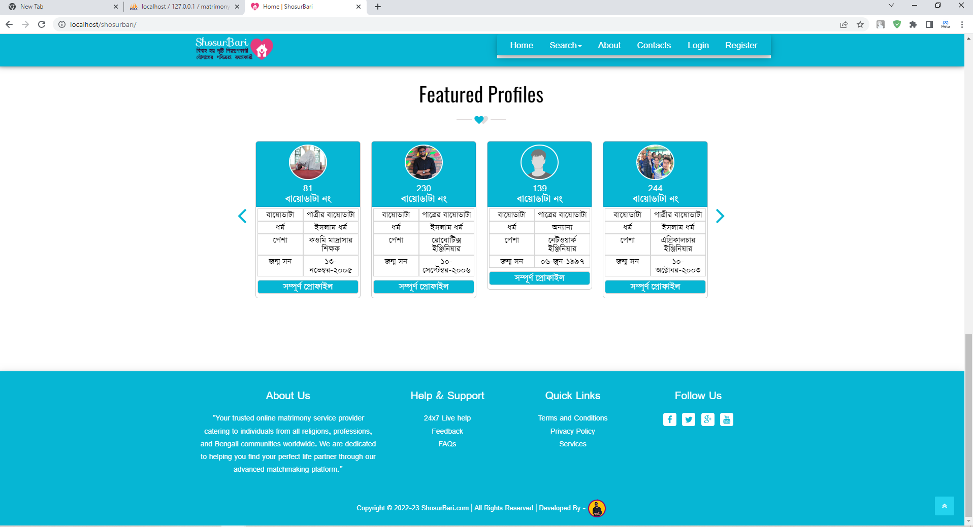

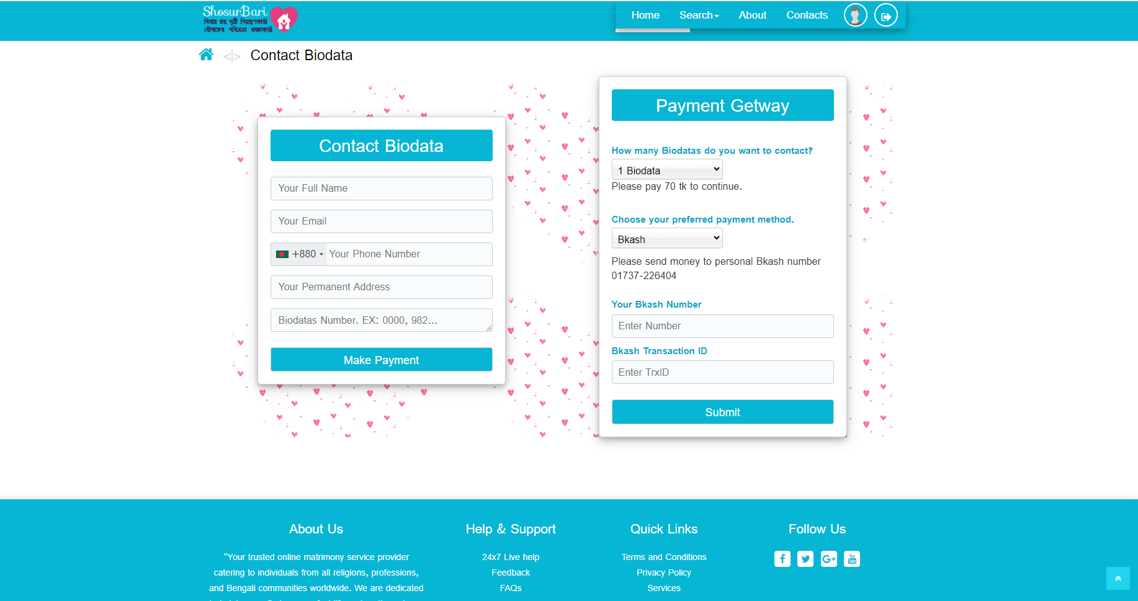

**Figure 12.1.2: Request Biodata Page**

**Figure 12.1.1: Home Page**

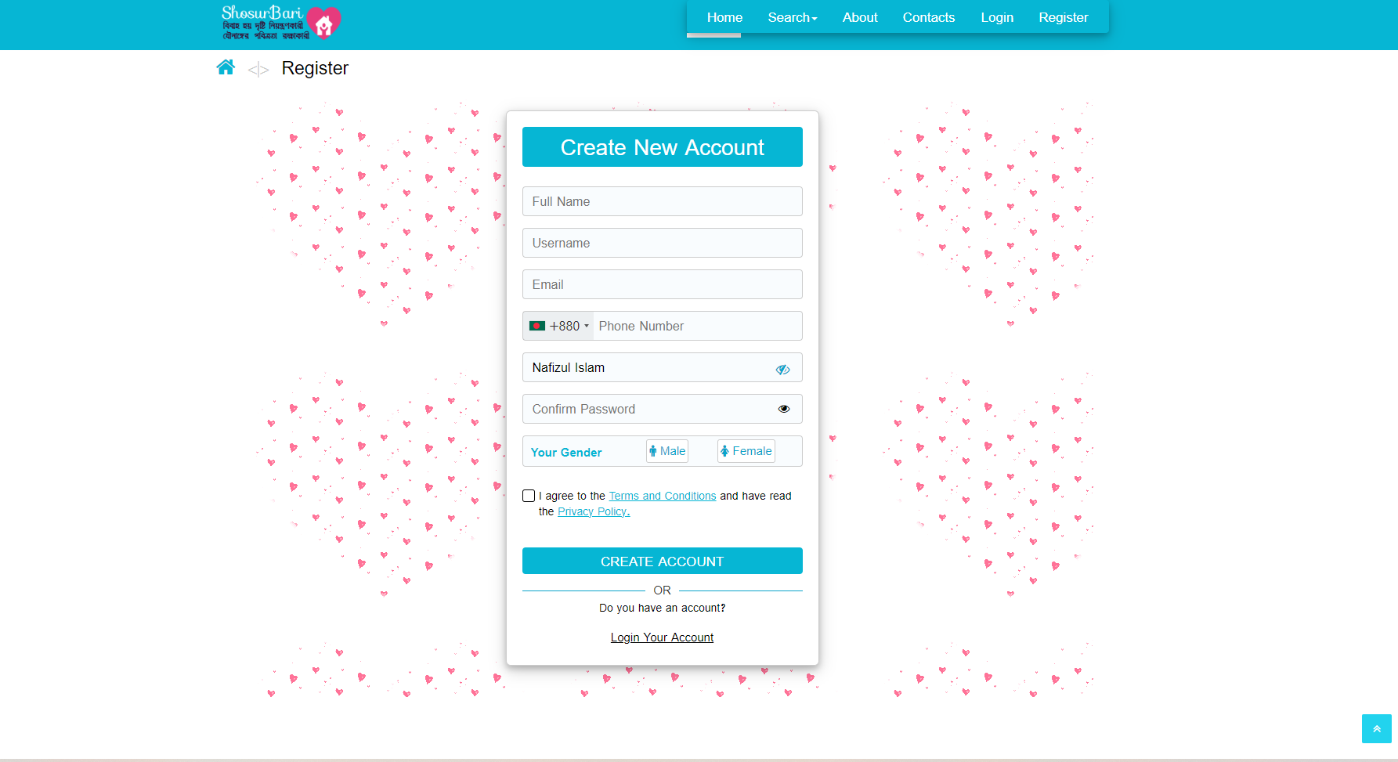

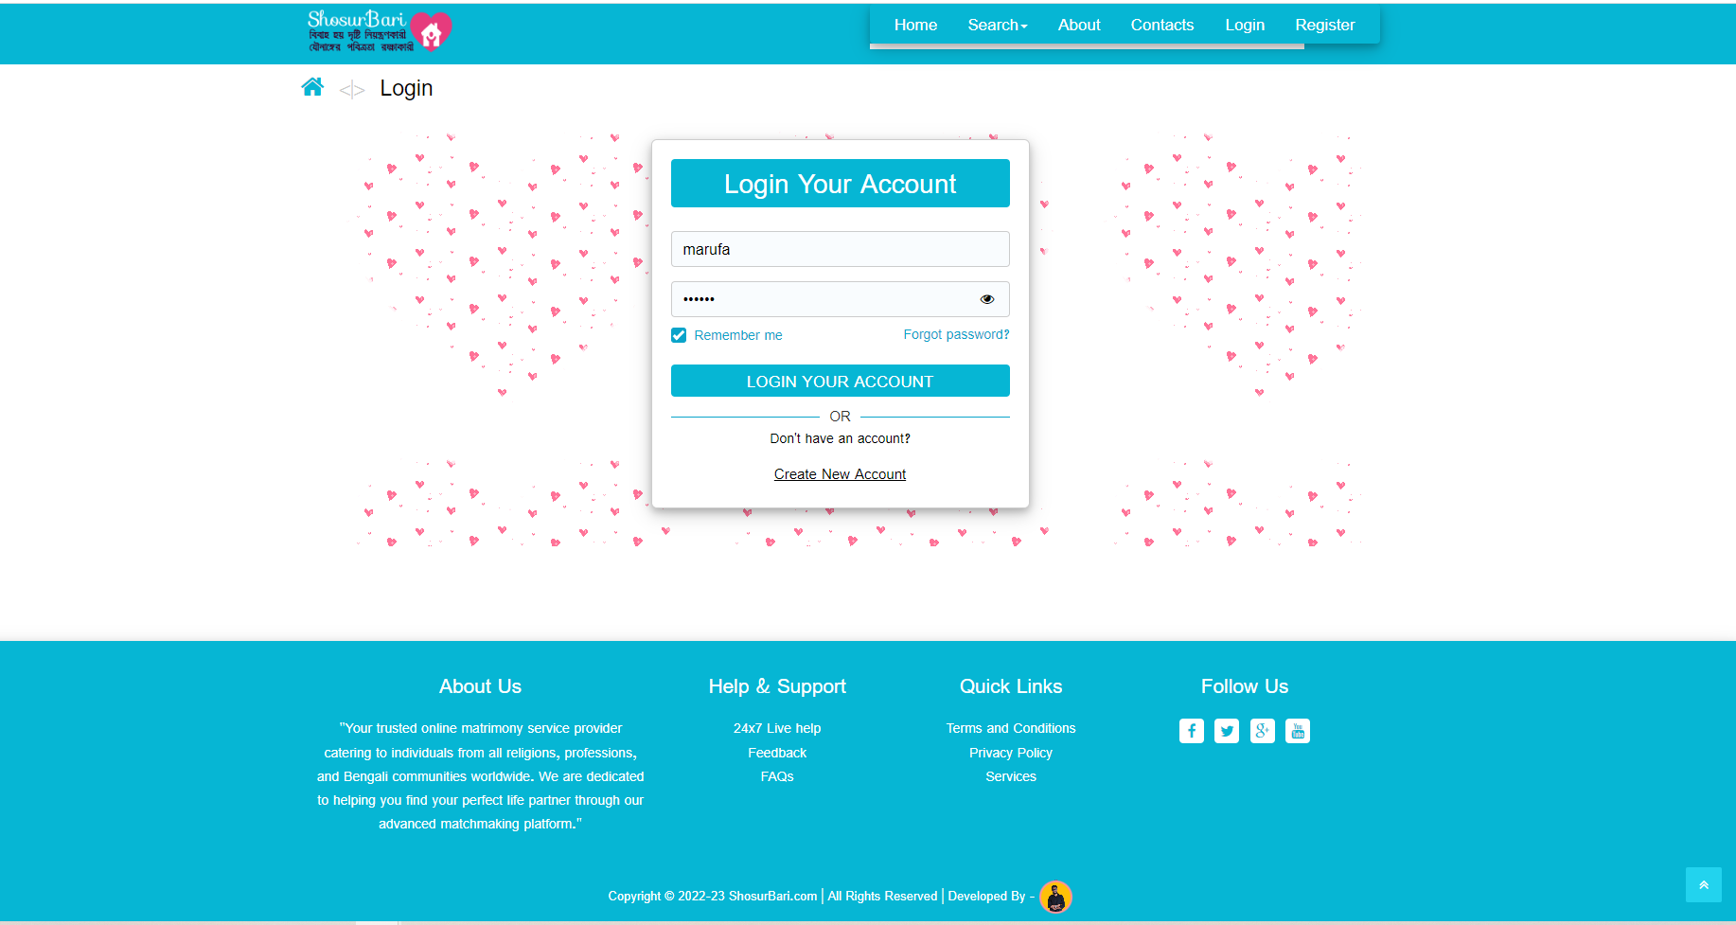

**Figure 12.1.3: Registration Page**

**Figure 12.1.4: Login Page**

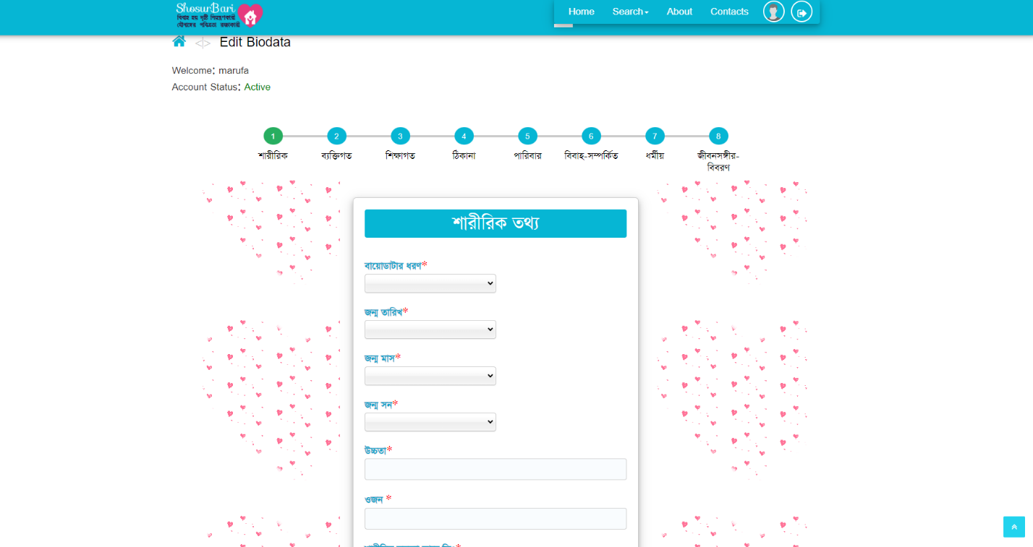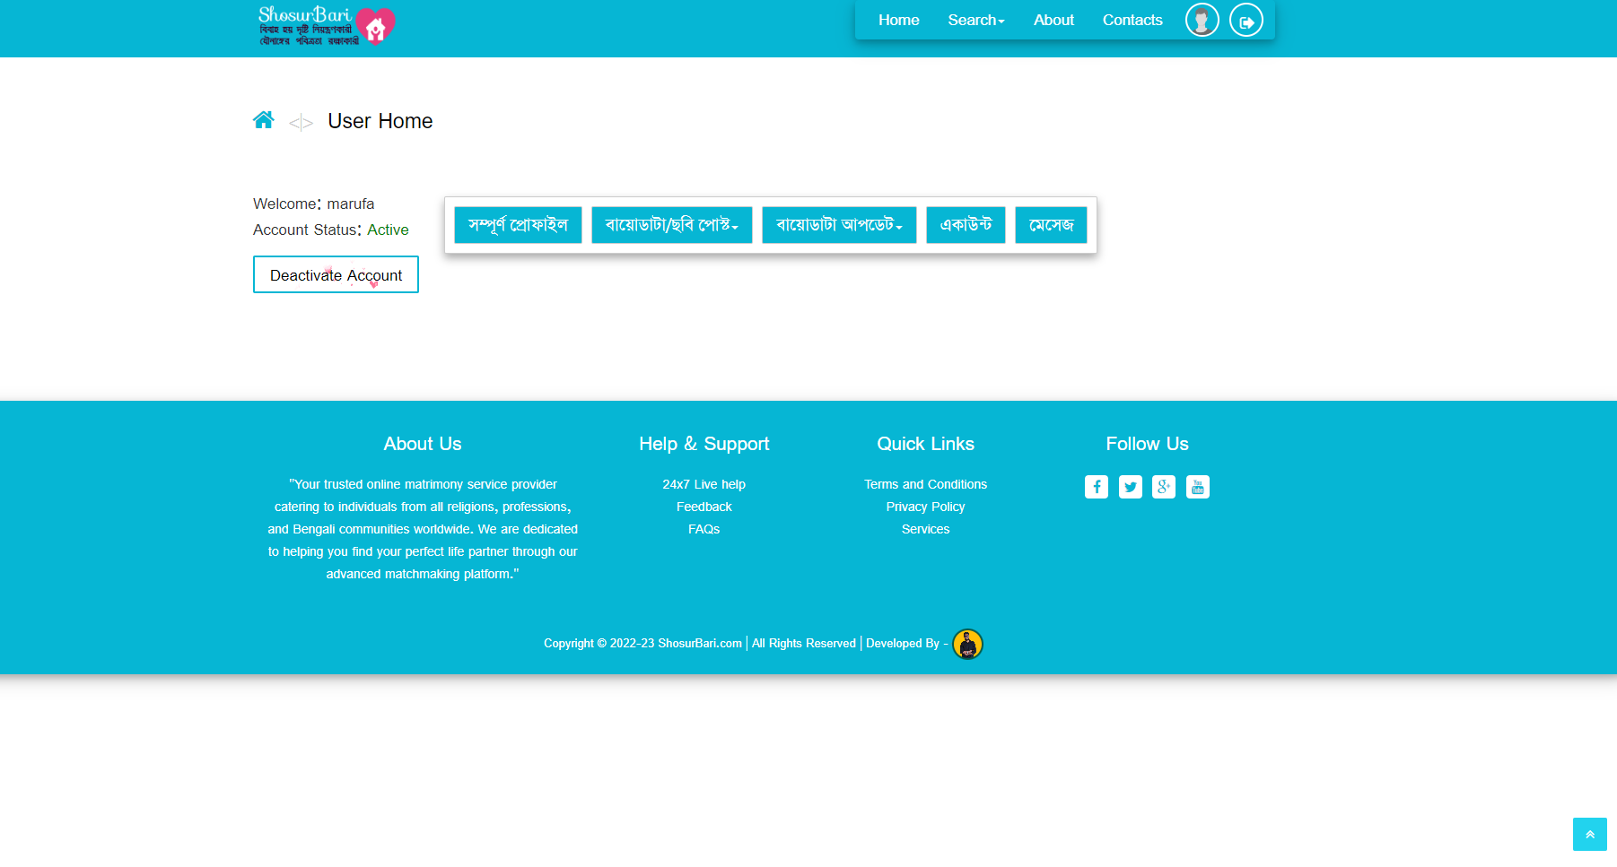

**Figure 12.1.6: Biodata Post Page**

**Figure 12.1.5: User Account Page**

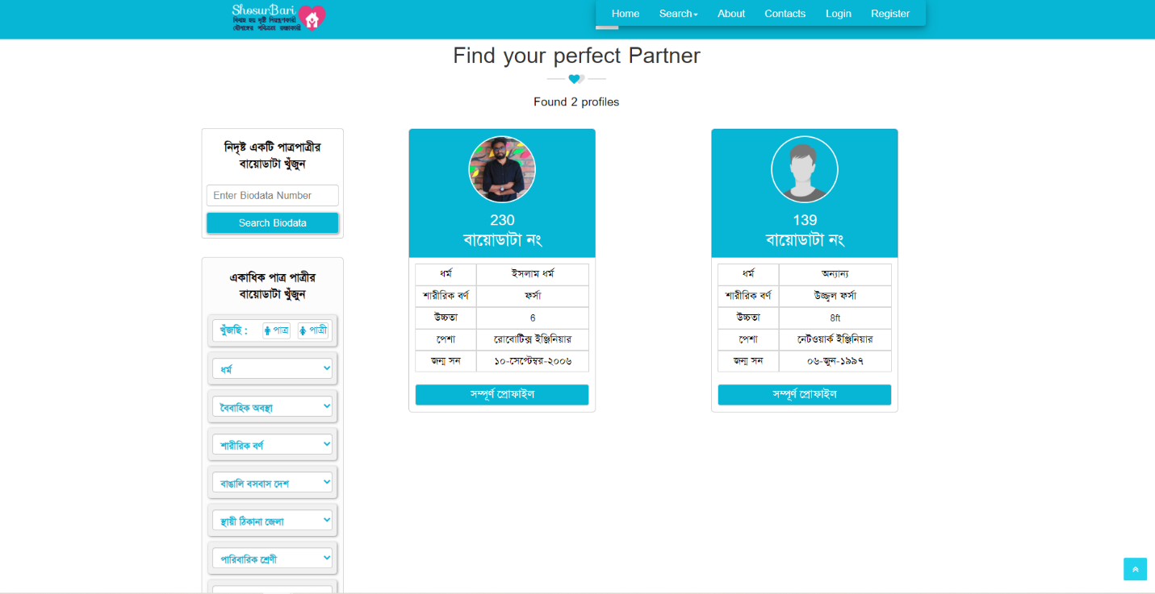

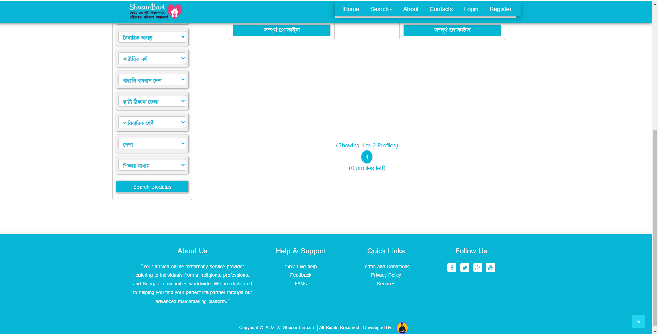

**Figure 12.1.8: Search Page**

**Figure 12.1.7: Search Page**

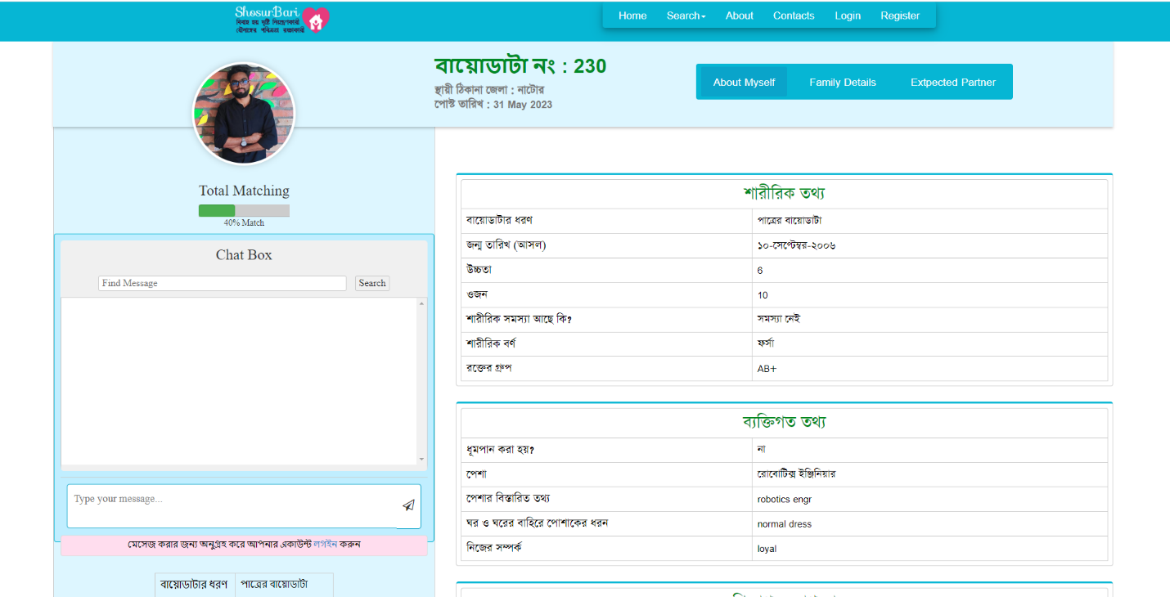

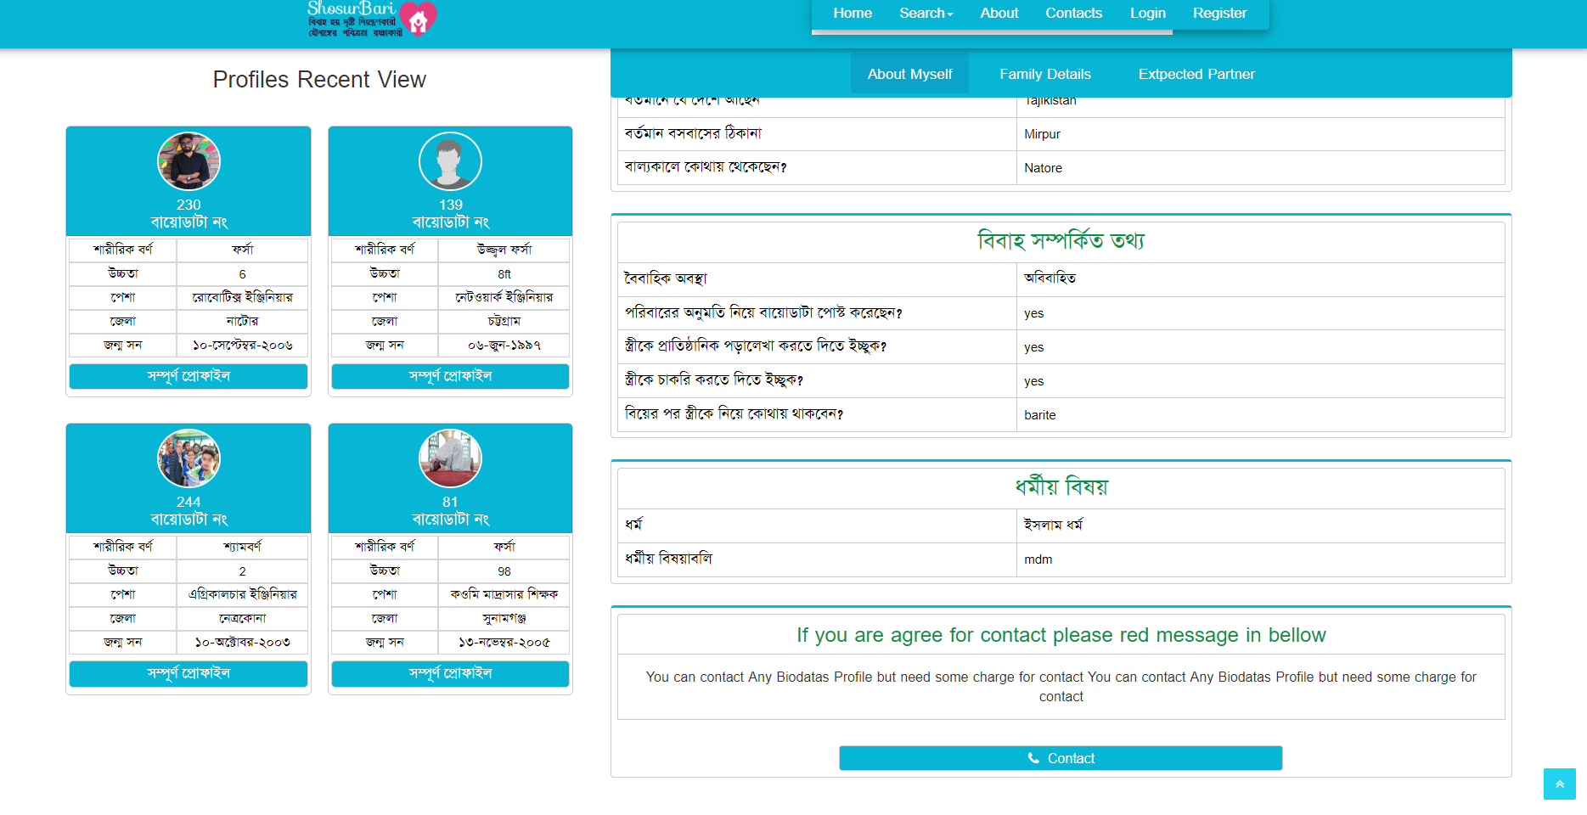

**Figure 12.1.10: Recent View Profile Portion**

**Figure 12.1.9: View Profile Page**

**12.2 Code Samples**

The code sample of our matrimonial web project showcases the integration of HTML, CSS, PHP, JavaScript, and MySQL to create a dynamic and interactive platform. PHP serves as the main programming language for the backend logic, while HTML, CSS, and JavaScript handle the frontend presentation and user interactions. Visual Studio is the chosen integrated development environment (IDE) for writing and managing the codebase.

In the codebase, HTML is used to structure the web pages and define the various elements of the user interface. CSS is employed to style and enhance the visual presentation, ensuring a modern and visually appealing design that aligns with the project's requirements. JavaScript adds interactivity and enhances the user experience with dynamic functionality such as form validation, interactive elements, and AJAX-based data retrieval.

The PHP code is responsible for handling the server-side processing, database interactions and dynamic content generation. It utilizes the MySQL database to store and retrieve user profiles, search results, messaging data, and other essential information. PHP interacts with the database through SQL queries, ensuring efficient data management and retrieval.

Visual Studio, a powerful IDE, provides a rich set of features for code editing, debugging, and project management. It offers a seamless development experience, allowing developers to write, test, and debug code efficiently.

The code sample demonstrates the implementation of key features of the matrimonial web project, such as user registration, login/authentication, search functionality, profile management, messaging system, and database interactions. It showcases clean and well-structured code, following best practices for security, scalability, and maintainability.

The use of PHP as the main programming language, combined with HTML, CSS, JavaScript, and MySQL, creates a robust and dynamic web application that offers a seamless user experience and facilitates meaningful connections between users.

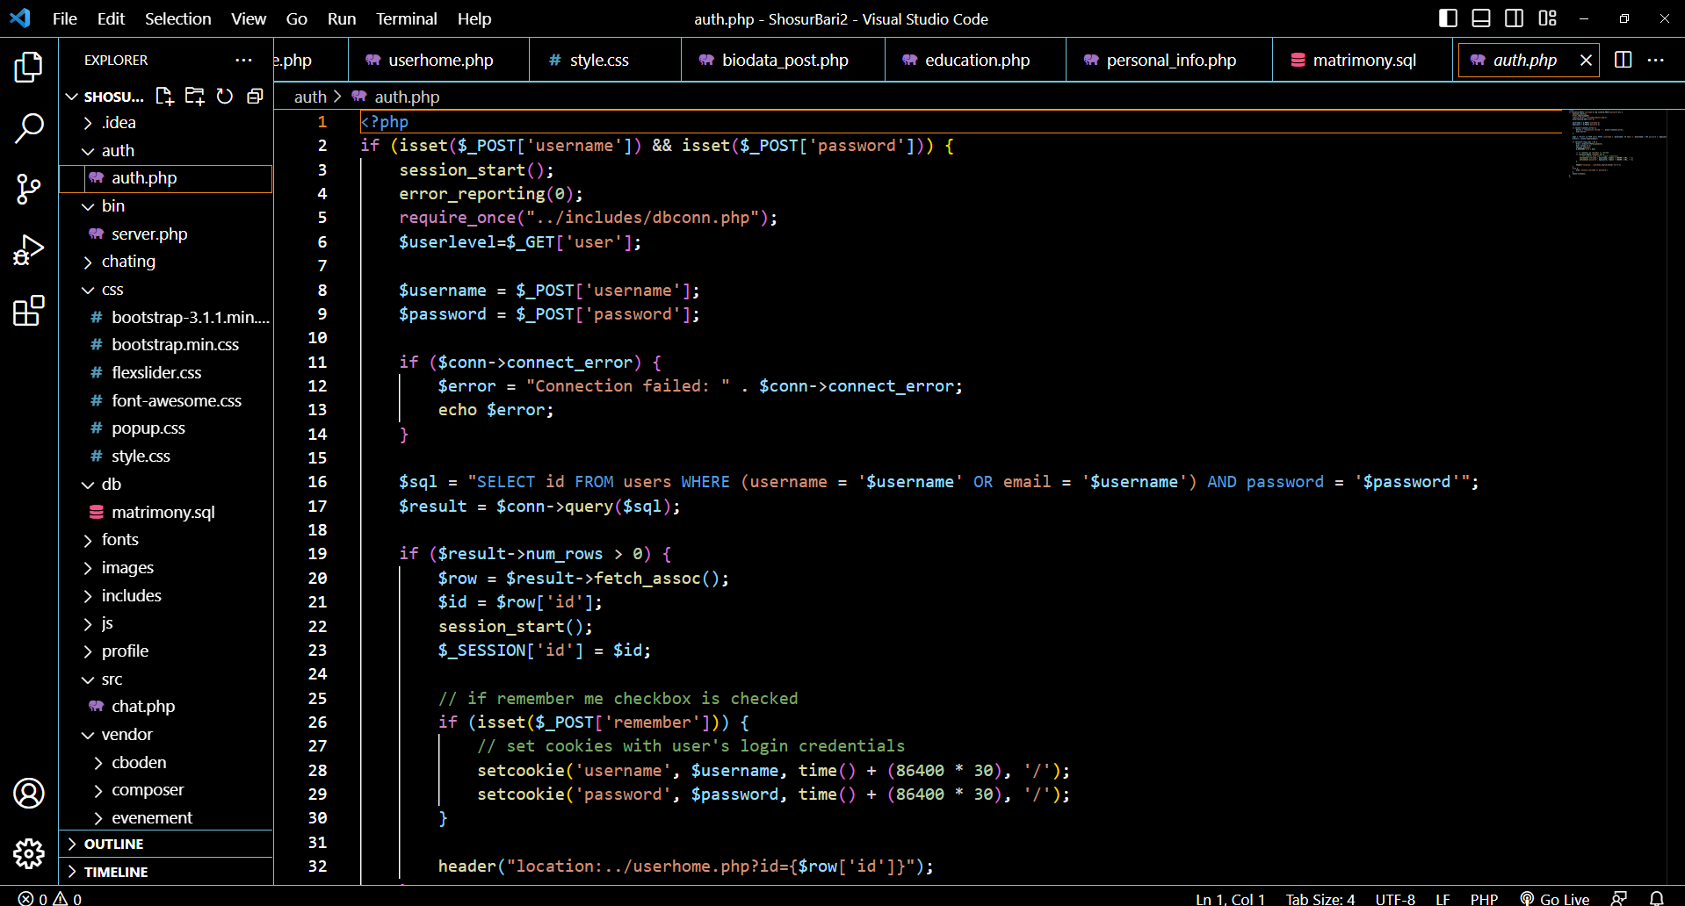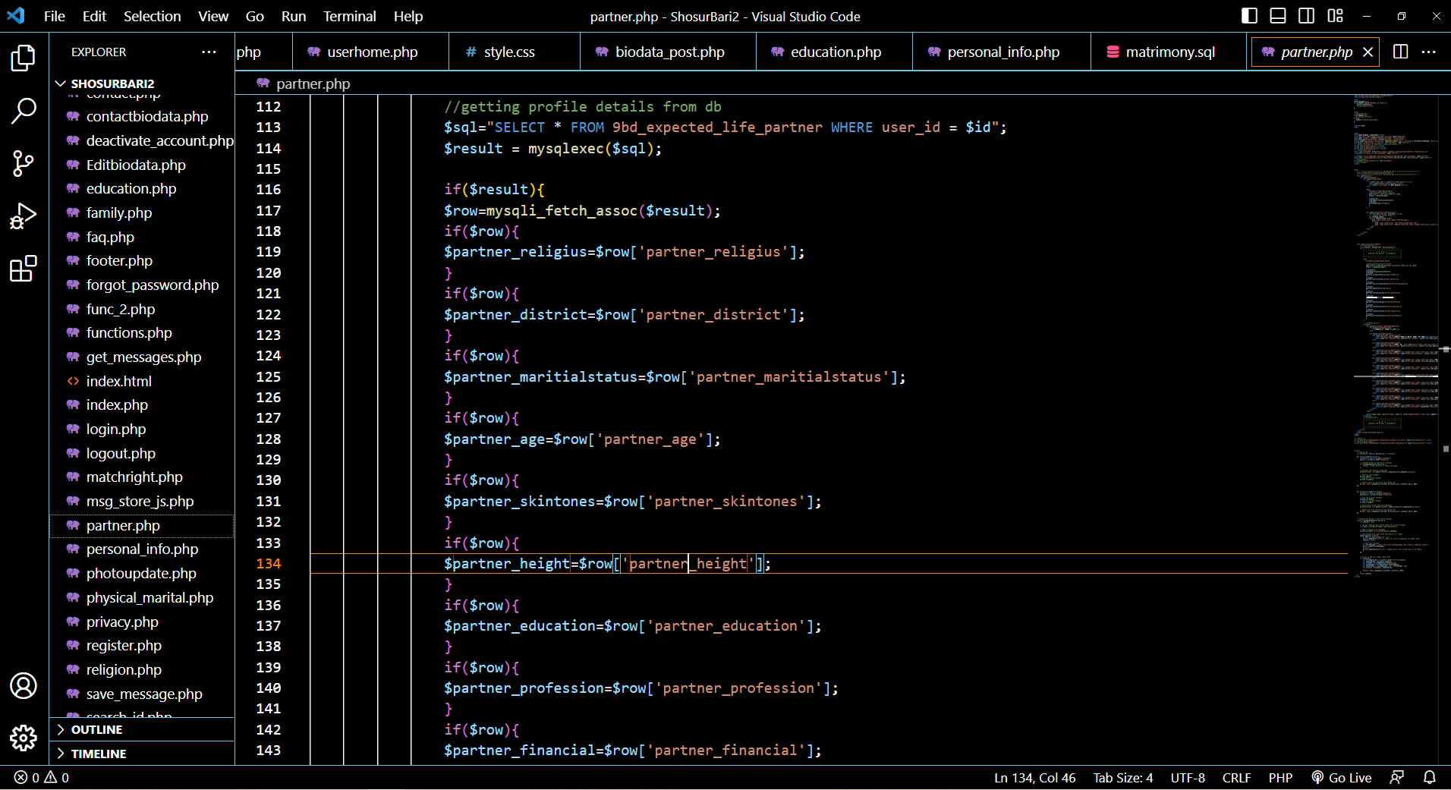

**Figure 12.2.2: Login Authentication File Portion**

**Figure 12.2.1: Partner File Portion**

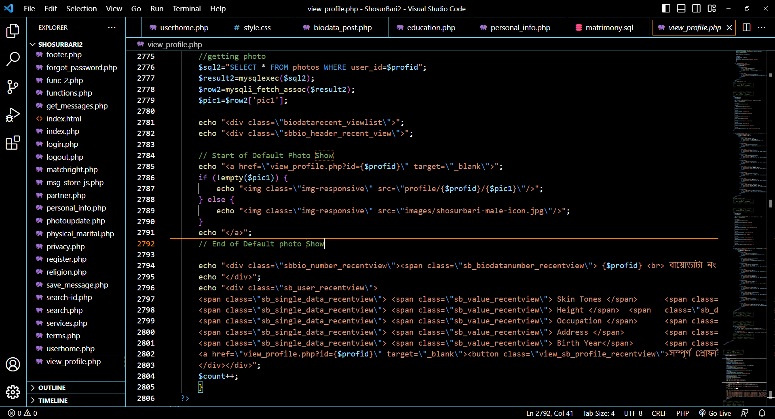

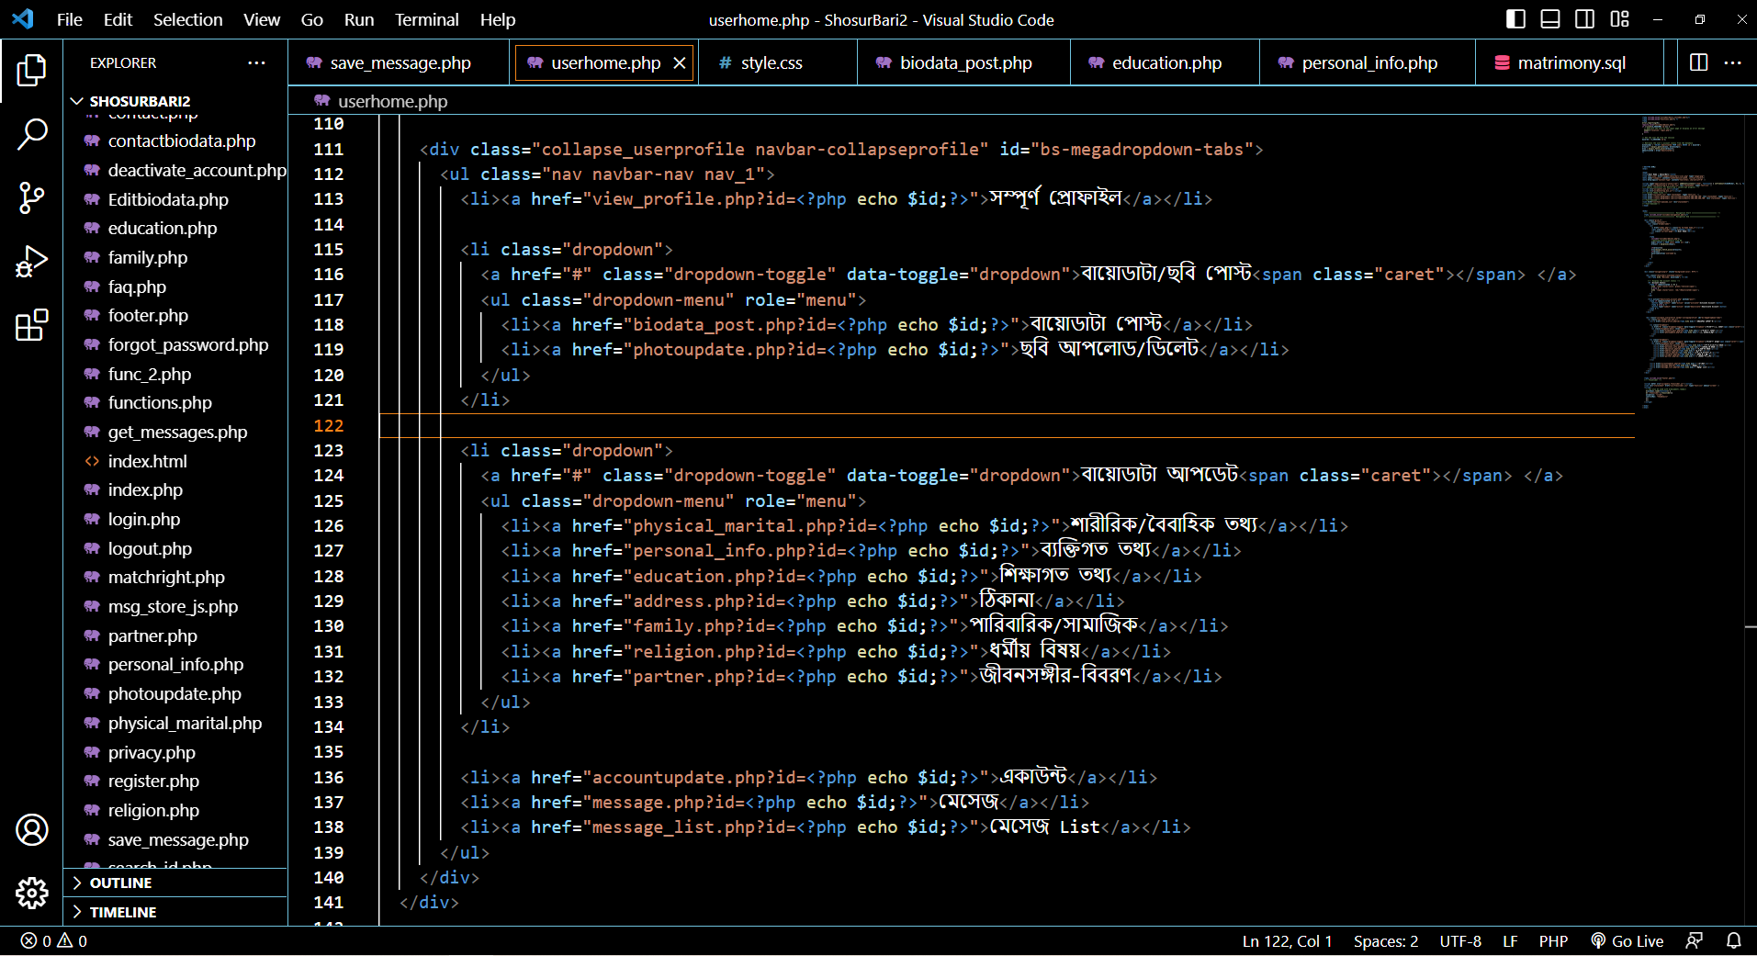

**Figure 12.2.4: User Home Page File Portion**

**Figure 12.2.3: View Profile Page File Portion**

**12.3 References and Citations**

**Design Concept:**

<https://ordhekdeen.com/>

[https://www.taslimamarriagemedia.com/](https://www.taslimamarriagemedia.com/page/about-us)

**Project Source:**

<https://projectworlds.in/free-projects/php-projects/online-matrimonial-project-in-php/>

<https://codepen.io/Paviethra_A/pen/yLKayOL>

**Document Source:**

<https://www.scribd.com/document/137087047/Shaadi-com>

https://www.freeprojectz.com/uml-diagram/marrige-buero-management-system-uml-diagram?

https://www.slideshare.net/parthgbhatt/rab-ne-bana-di-jodi-online-matrimonial

https://www.academia.edu/43102557/SRS_Matrimonial_Website

https://www.lovelycoding.org/online-matrimonial-management-system/

https://creately.com/diagram/example/jrkstpdb2/admin-activity-classic

<https://meeraacademy.com/activity-diagram-for-matrimonial-website-project/>

**GitHub Link:**

https://github.com/NAFIZ-SWE-DIU/ShosurBari.com